Ideation Phase
Define the Problem Statements

Date | 17 Feb 2026
Team ID | 699ec7849962d99304ab7b76
Project Name | Drishyamitra AI-Powered Photo Management System
Maximum Marks | 2 Marks

Customer Problem Statement Template:
Create a problem statement to understand your customer's point of view. The Customer Problem Statement template helps you focus on what matters to create experiences people will love.
A well-articulated customer problem statement allows you and your team to find the ideal solution for the challenges your customers face. Throughout the process, you’ll also be able to empathize with your customers, which helps you better understand how they perceive your product or service.
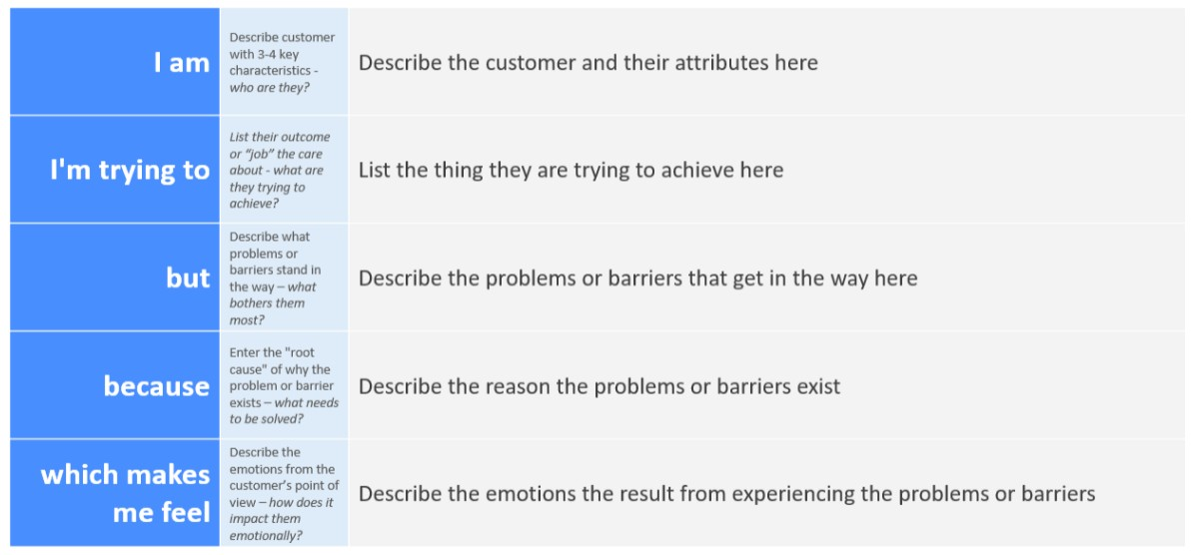
Example:
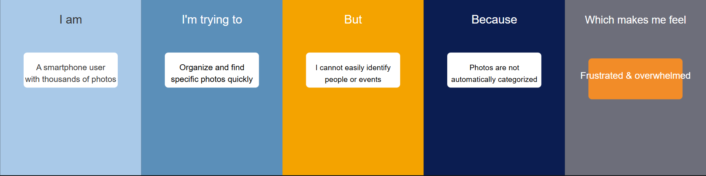

Problem  Statement (PS) | I am  (Customer) | I’m trying to | But | Because | Which makes me feel
PS-1 | A smartphone user with thousands of photos | Organize and find specific photos quickly | I cannot easily identify people or events in my gallery | Photos are not automatically categorized or tagged | Frustrated and overwhelmed
PS-2 | A user who wants to share photos with friends or family | Send photos of specific people or events | I need to manually search and select photos | Traditional gallery apps do not support AI-based face recognition and smart search | Time-consuming and inconvenient
PS-3 | A social media user | Quickly deliver photos to contacts | Sharing photos across multiple platforms requires many steps | Apps are not integrated with email or WhatsApp automation | Annoyed and less productive

